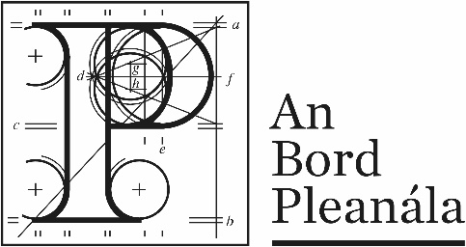
Documents received at Oral Hearing for
ABP-314232-22

Case Description | DART+ West Railway Order - Dublin City to Maynooth and M3 Parkway County Dublin, County Meath, County Kildare
Date | 6th October, 2023
Location | The Gresham Hotel, 23 O’Connell Street Upper, North City, Dublin, D01 C3W7

Documents received at Oral Hearing
No. | Submitted by | Presenter | Topic
 | Pat Allison | Didn’t present today | Module C – Images Post Office
 | Kirkpatrick Rockfield Coolmine Residents’ Association | Anne Sheridan | Module C - Submission
 | Kevin O’Ceallaigh | Kevin O’Ceallaigh | Module C - Submission
 | Ciara O’Neill | Brian O’Connor | Module C - Submission
 | Patrick Lynch | Brian O’Connor | Module C - Submission

